Module 5:
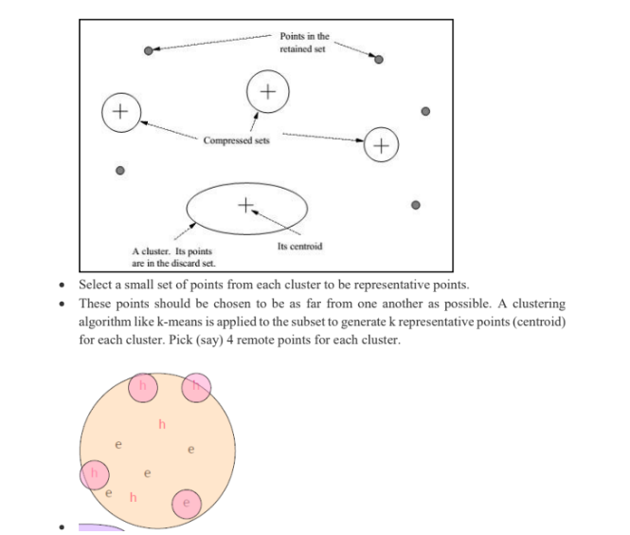
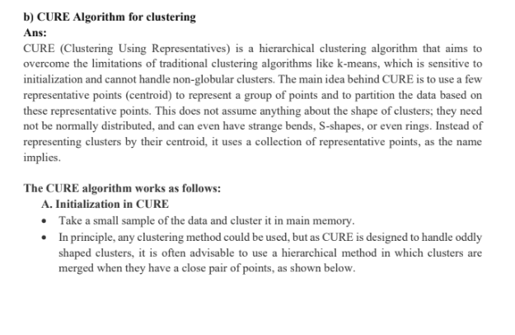
- Explain CURE algorithm for large scale clustering.

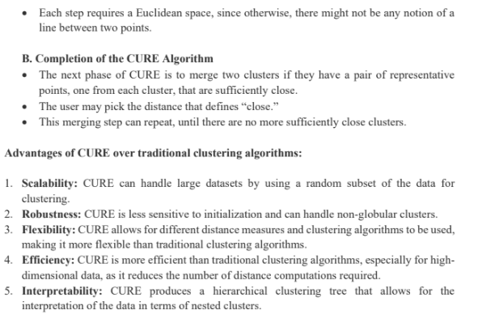
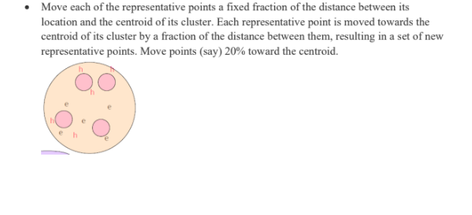

2. Explain clearly with diagram the PCY method of finding frequent item-sets (pairs) in a large
data set.
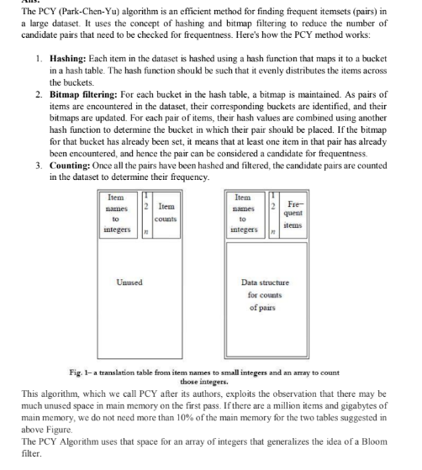

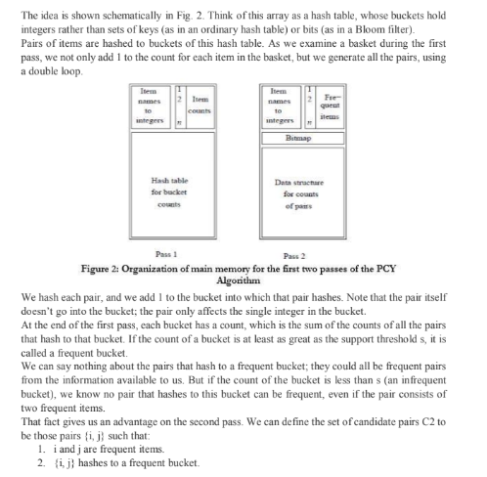

3. Explain the working principle of the SON Algorithm for mining frequent itemsets in large
datasets.
4. Discuss the concept of parallel SVM and its importance in handling large-scale datasets.

5. Define different distance matrices and provide the mathematical formula used to calculate it.
